Prod support commands:

Ls

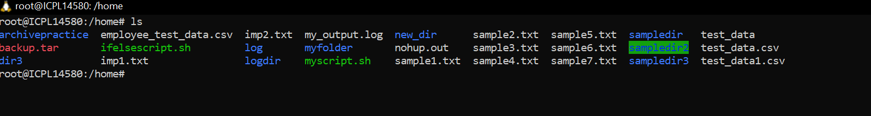

Cd

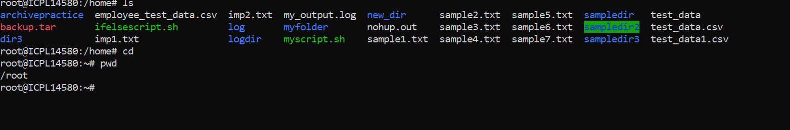

Mkdir

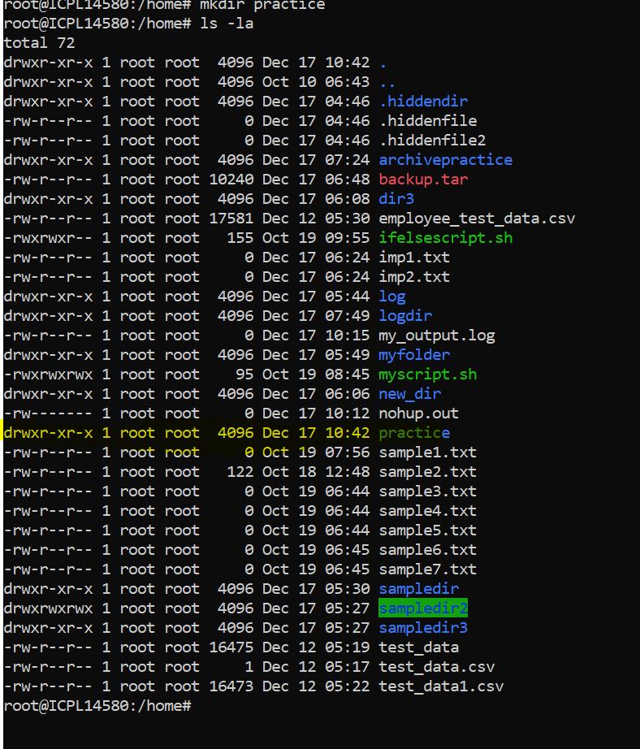

Rm

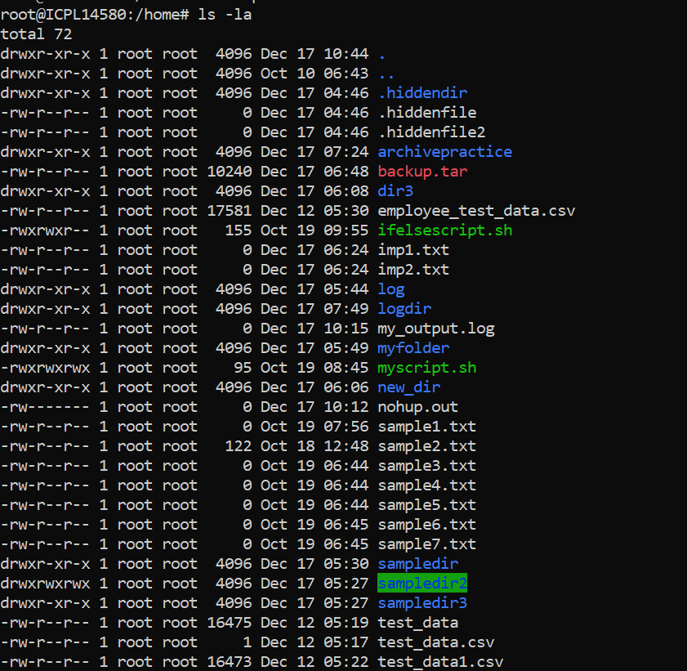

Cp command

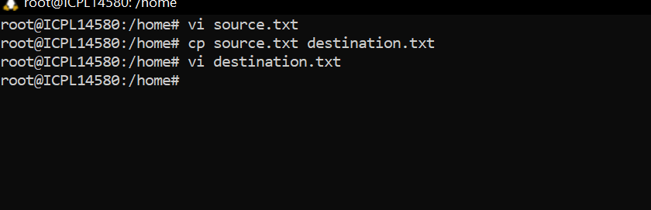

Mv command

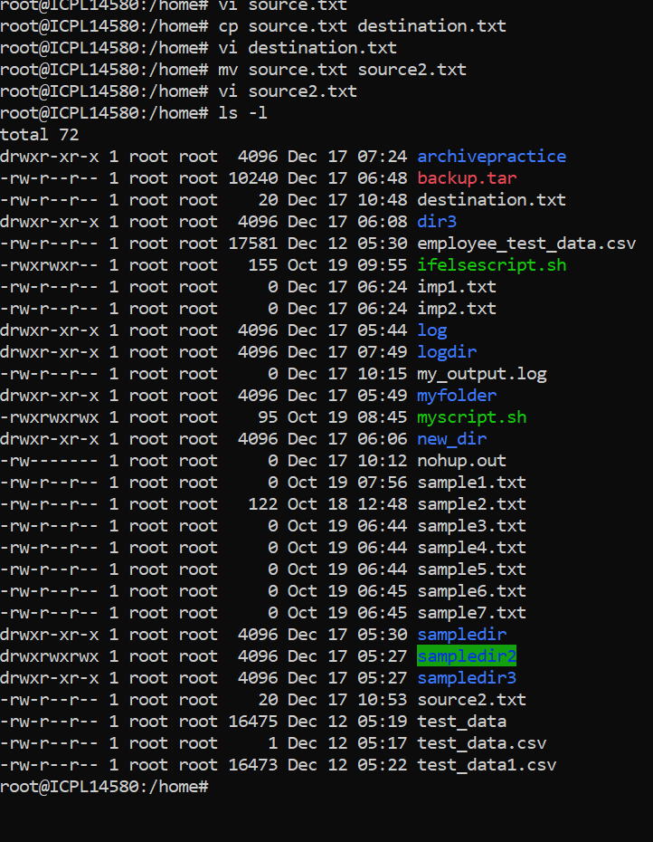

Chmod:

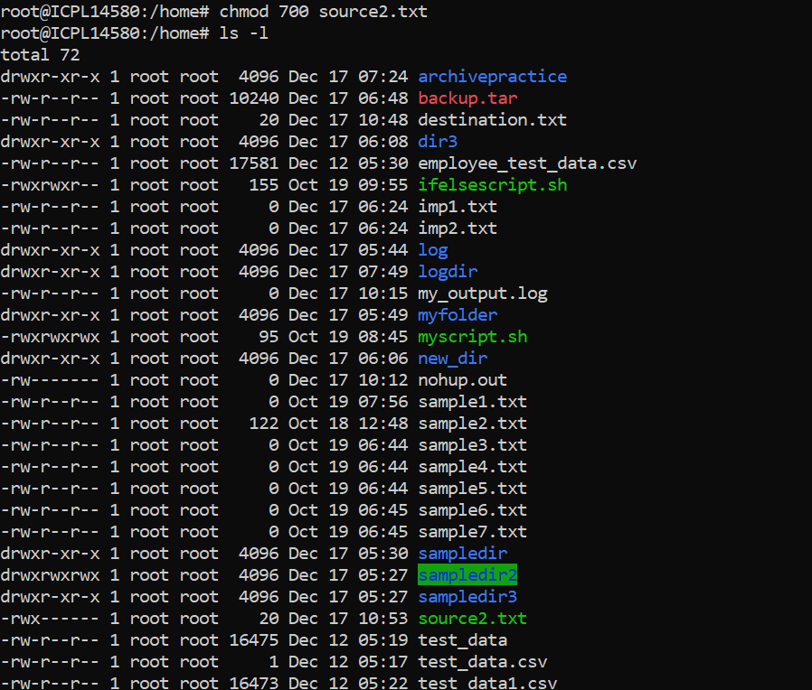

Df and du

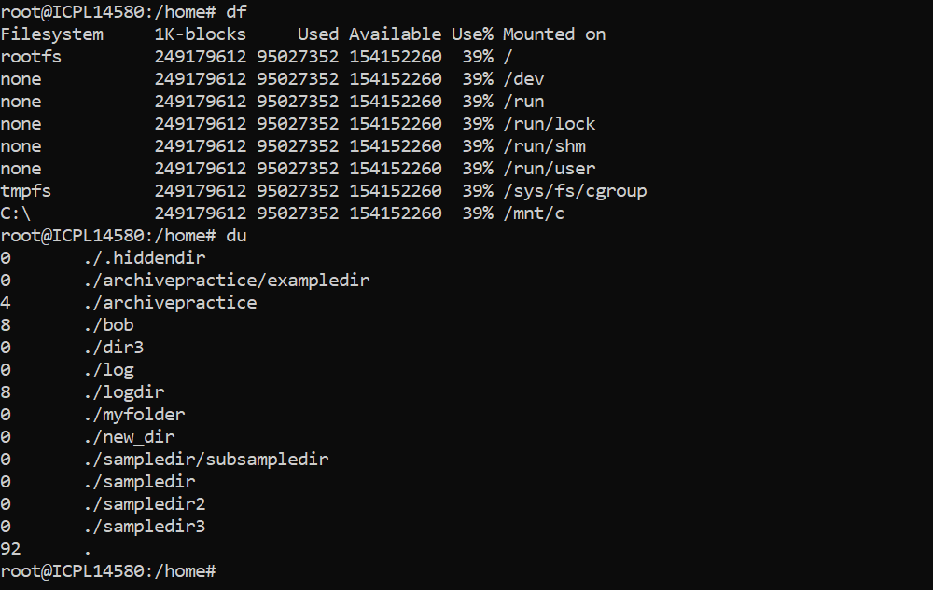

Ps

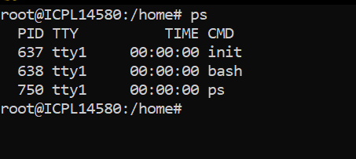

Top

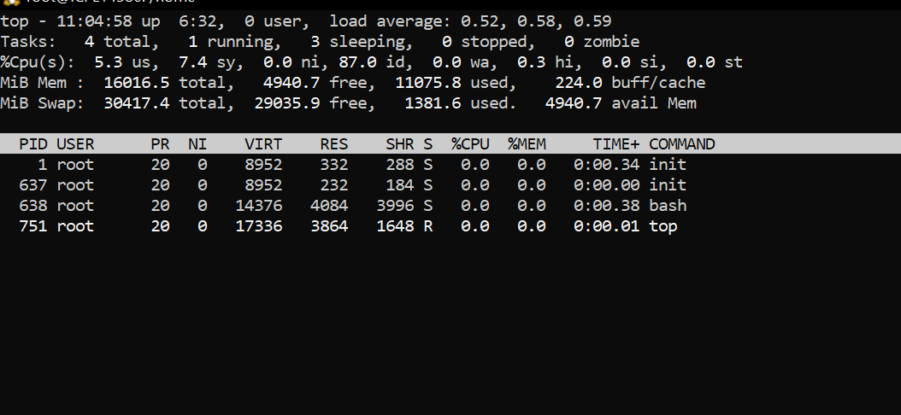

Htop

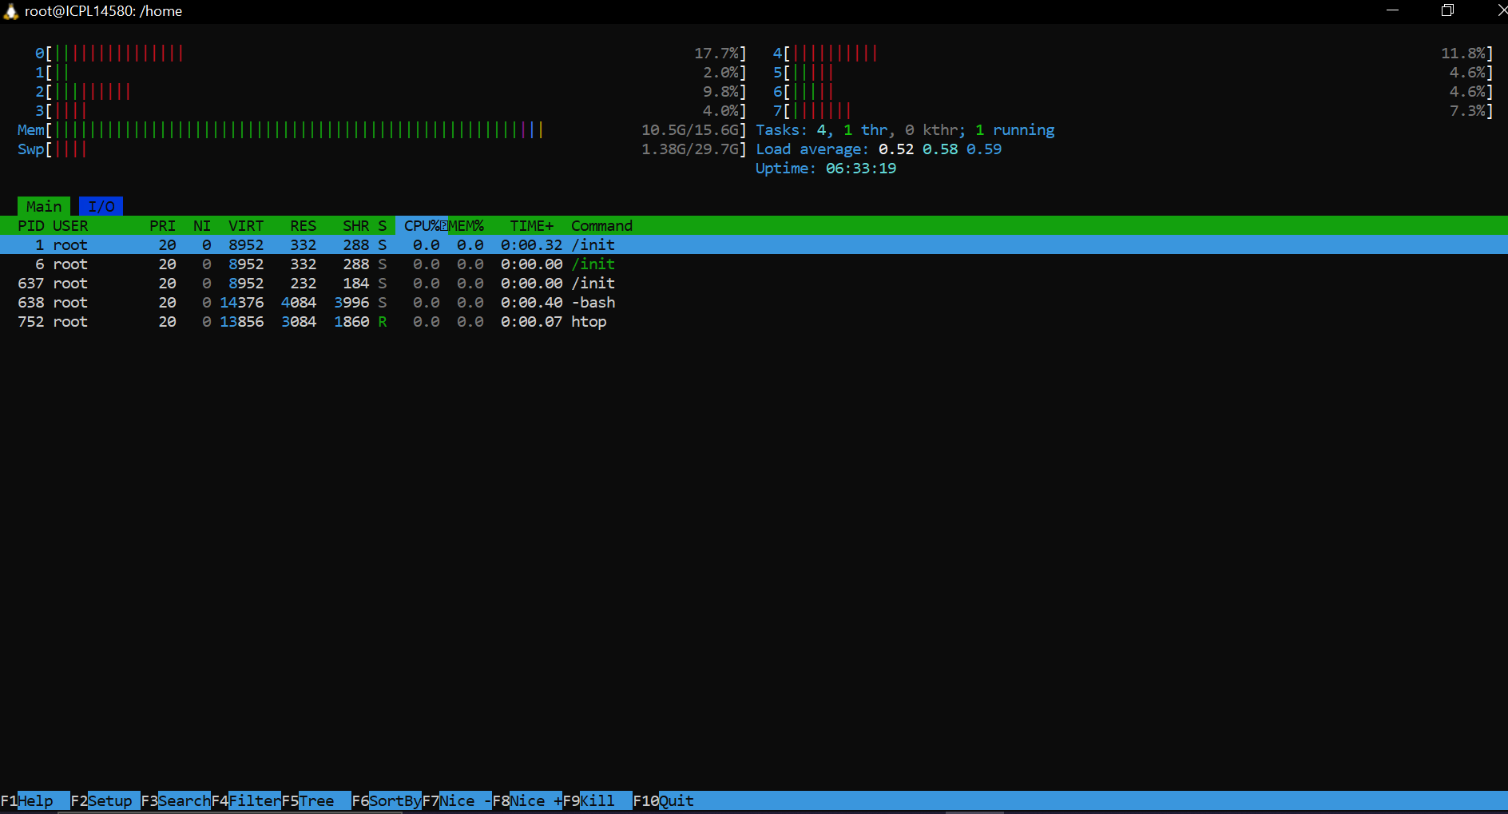

Kill

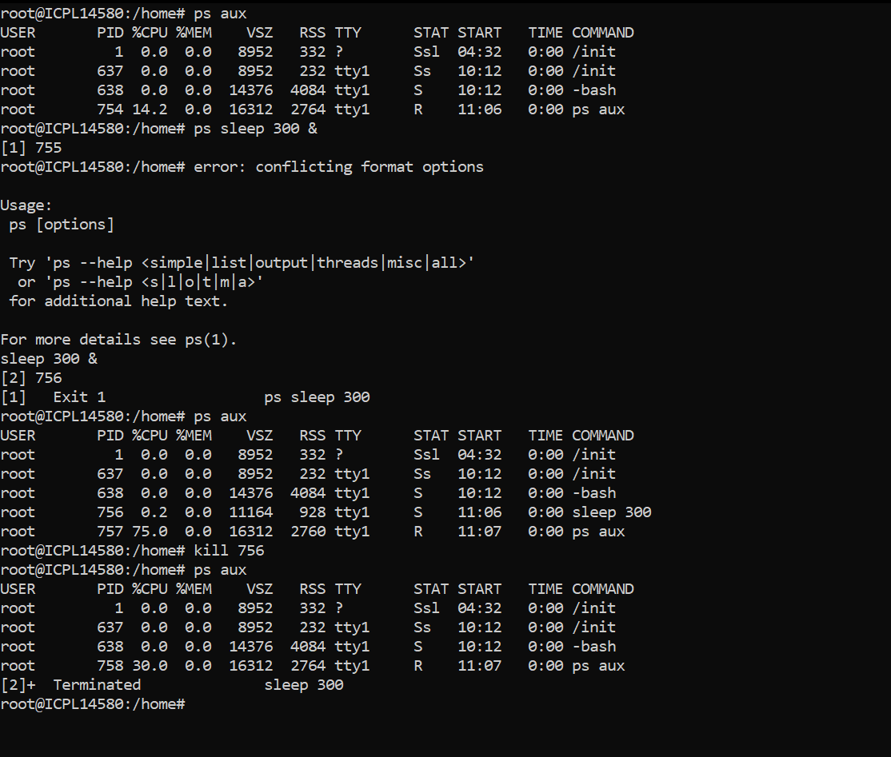

Pkill

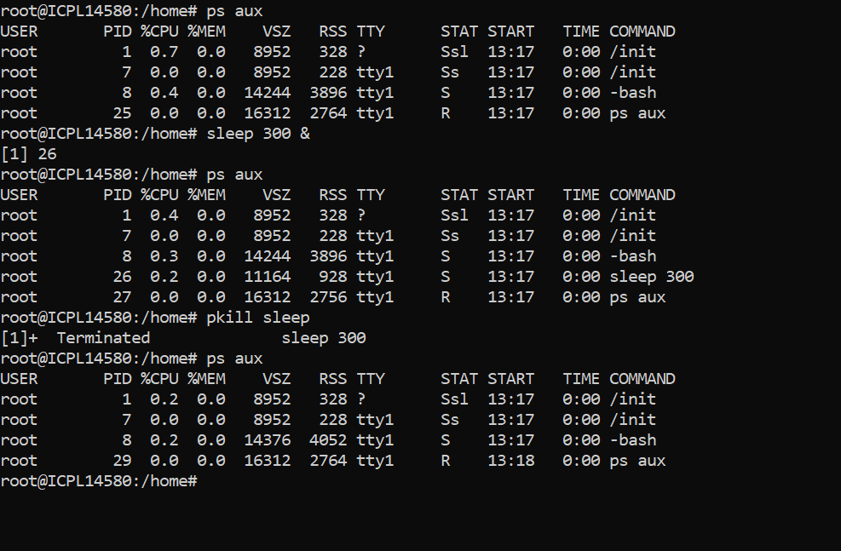

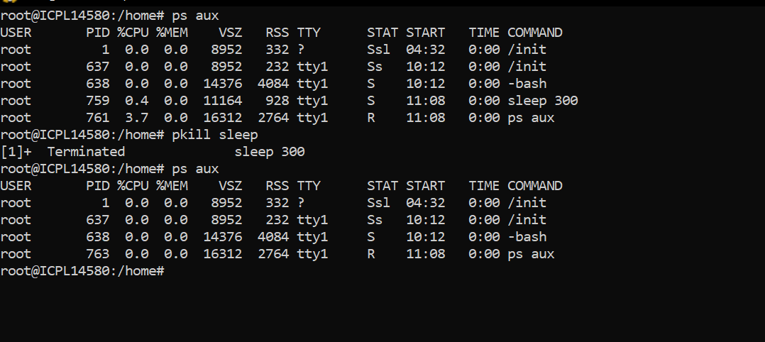

Nice and renice

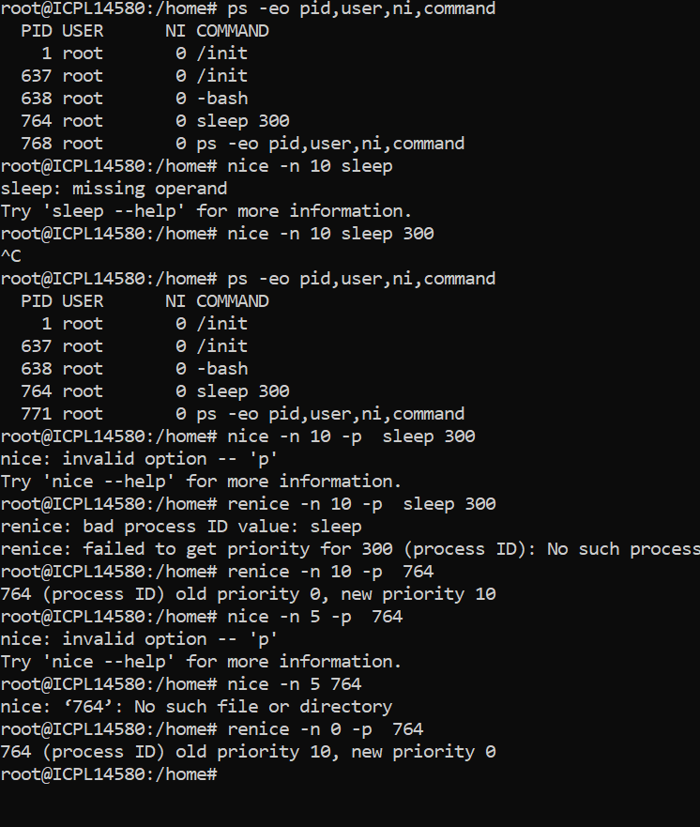

Nohup

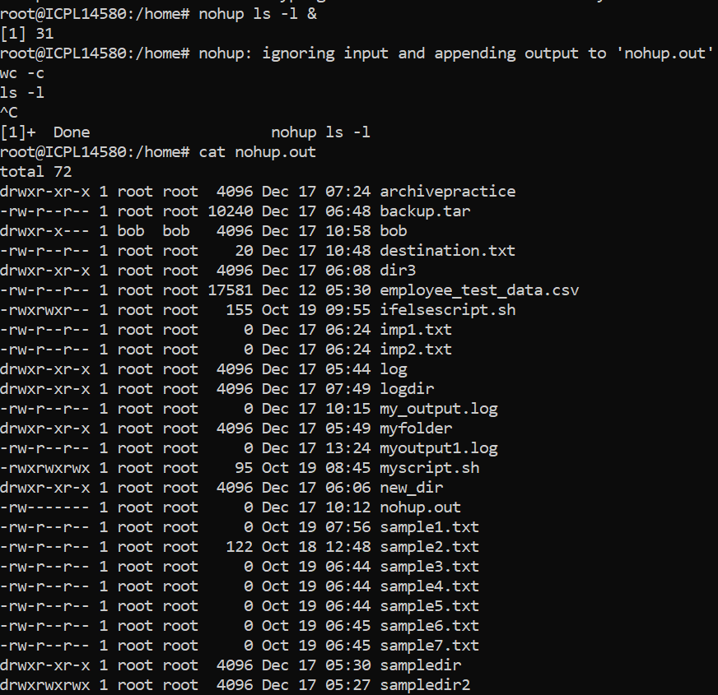

Ping

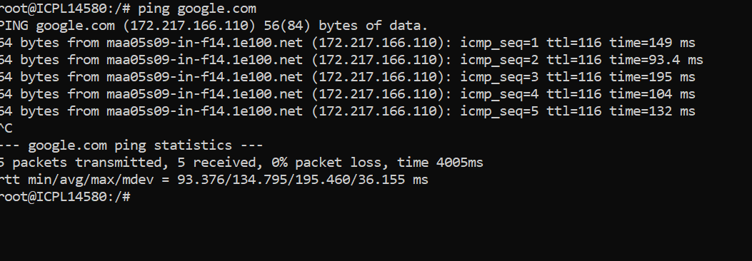

Netstat:

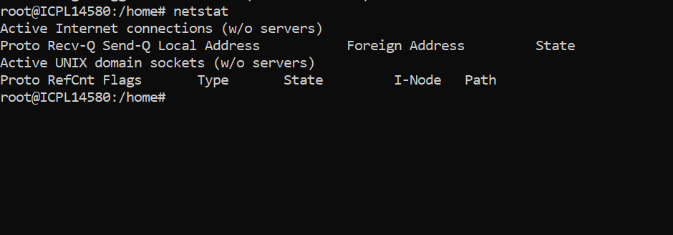

Ss

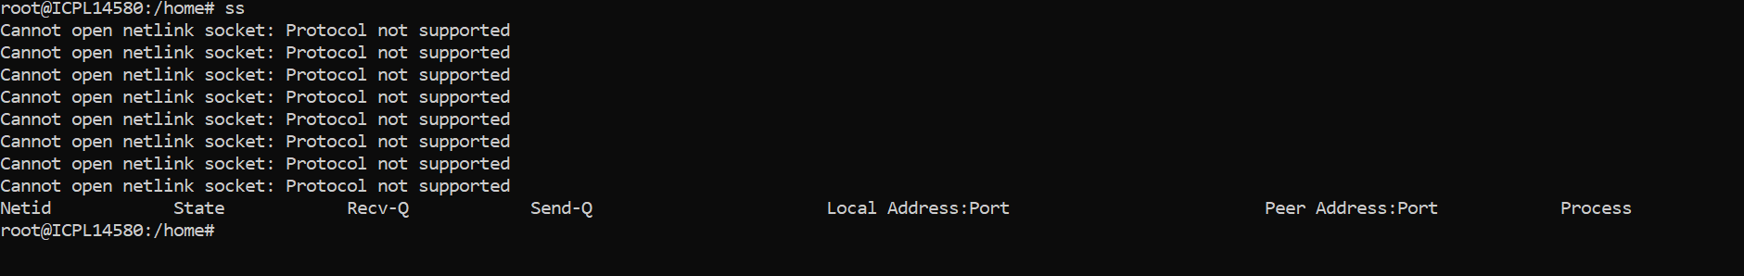

Ifconfig

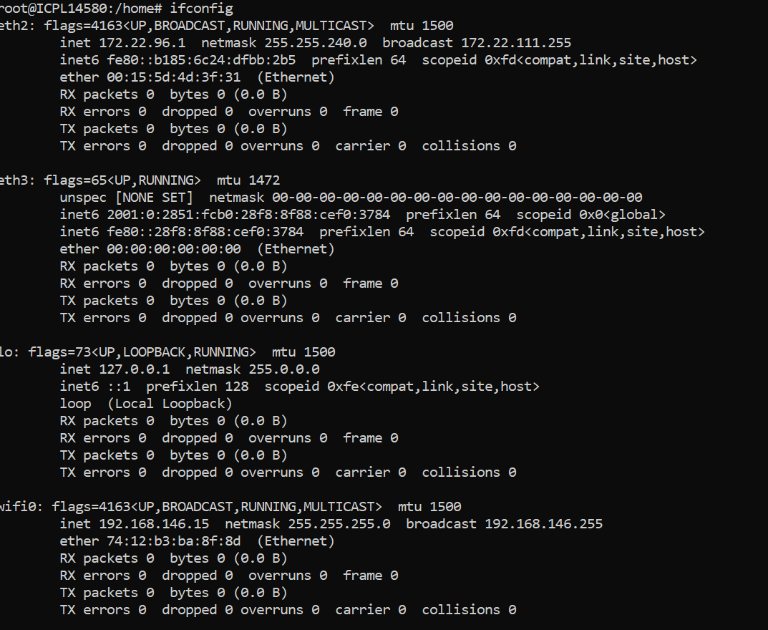

Ip

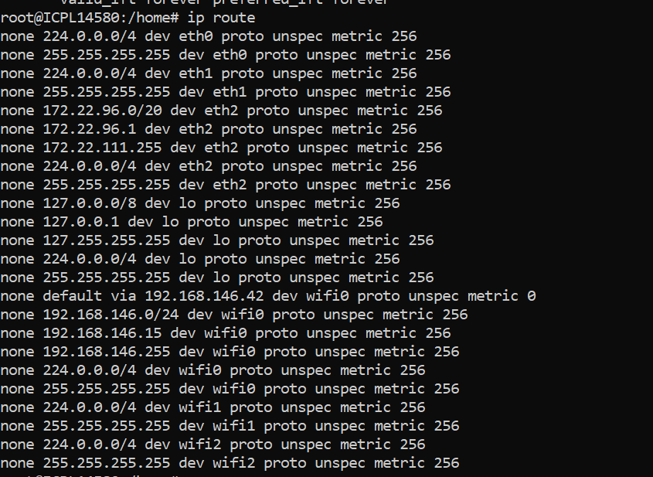

Uptime



Iostat

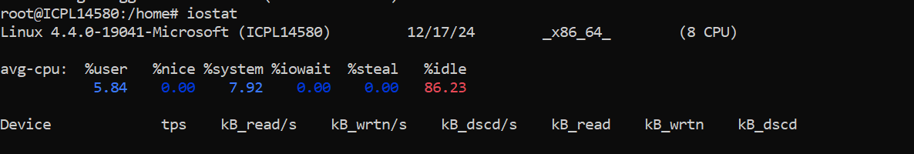

Free

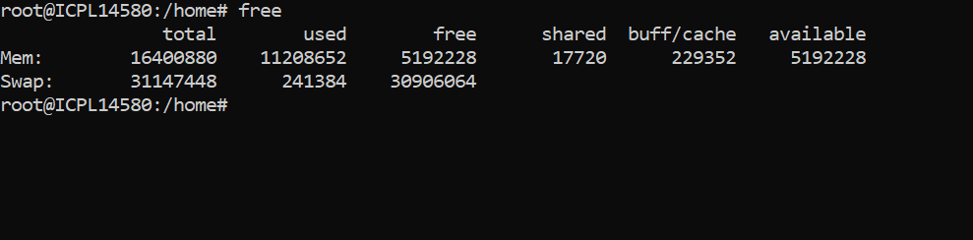

Dmesg

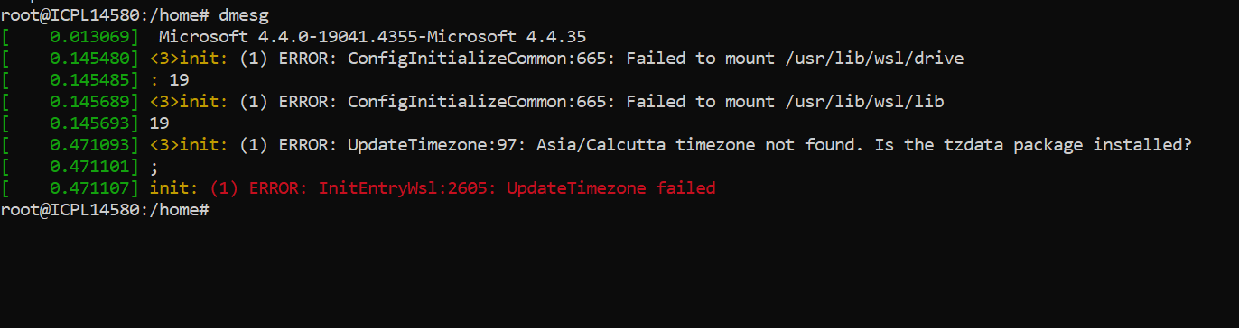

Sar



Lsof

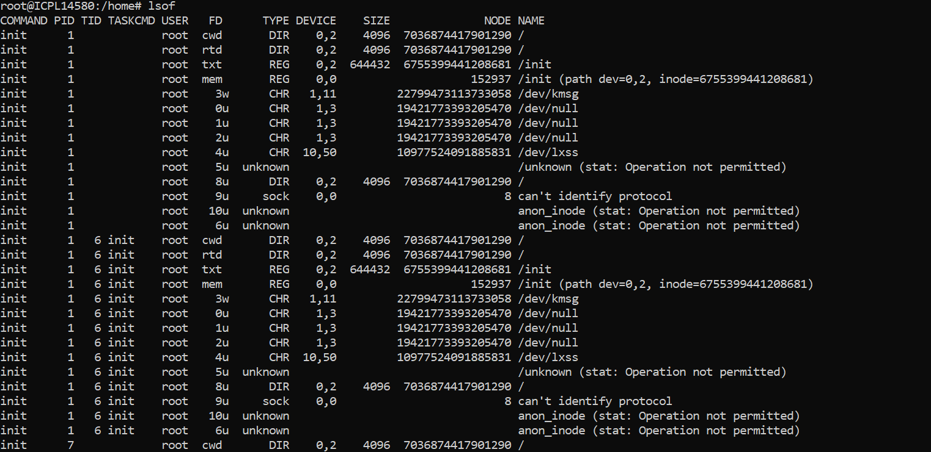

Iotop



Df and du

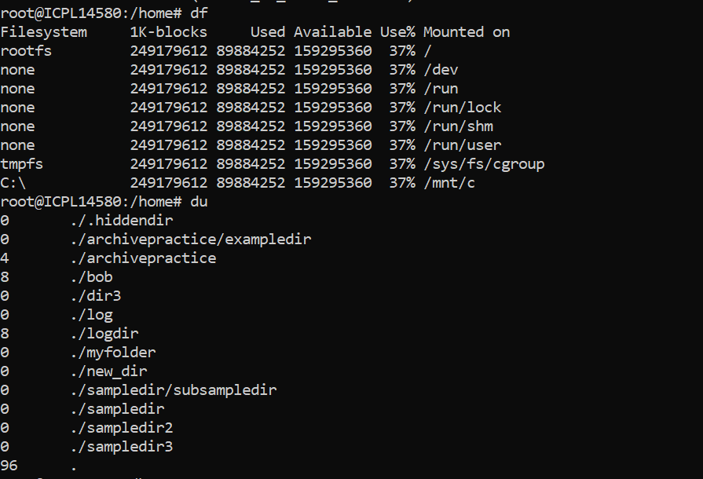

W



Last

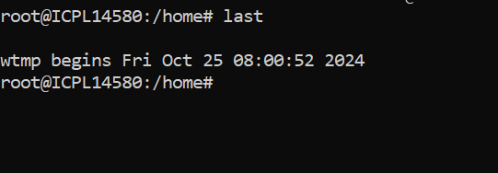

Tail

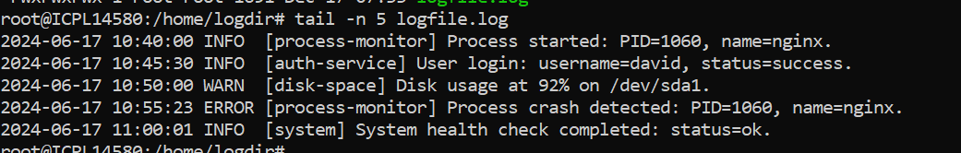

Head

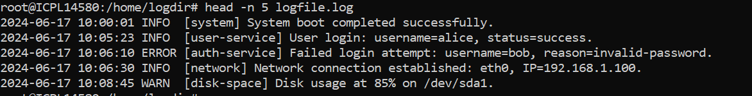

Grep



Less

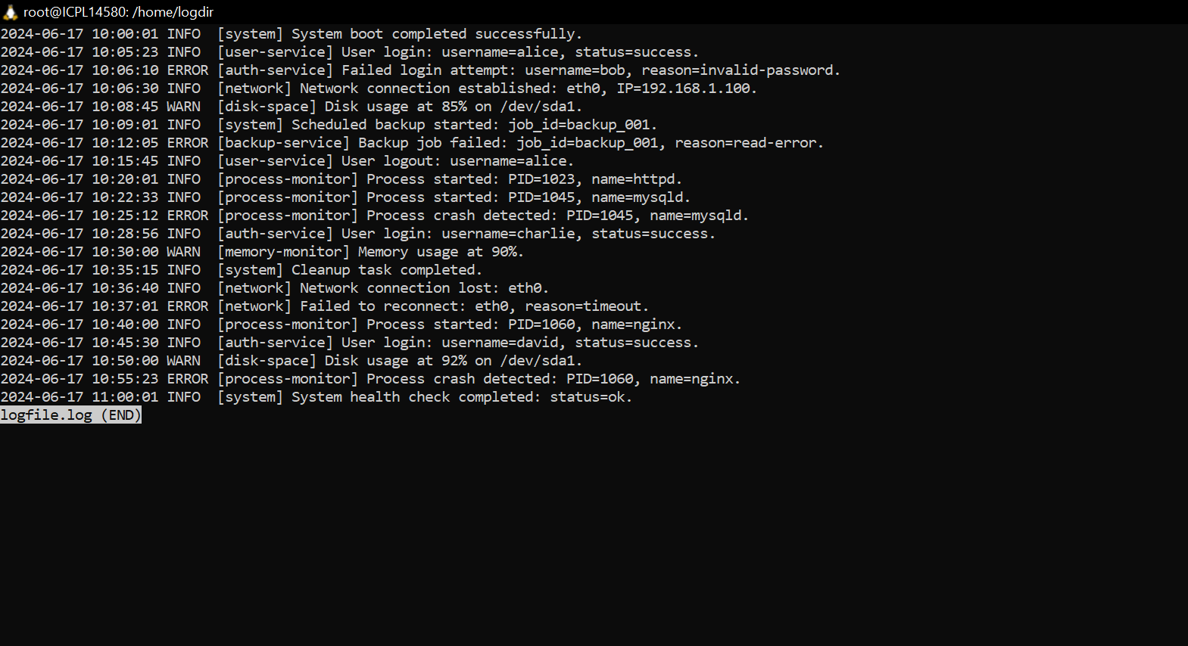

Cat

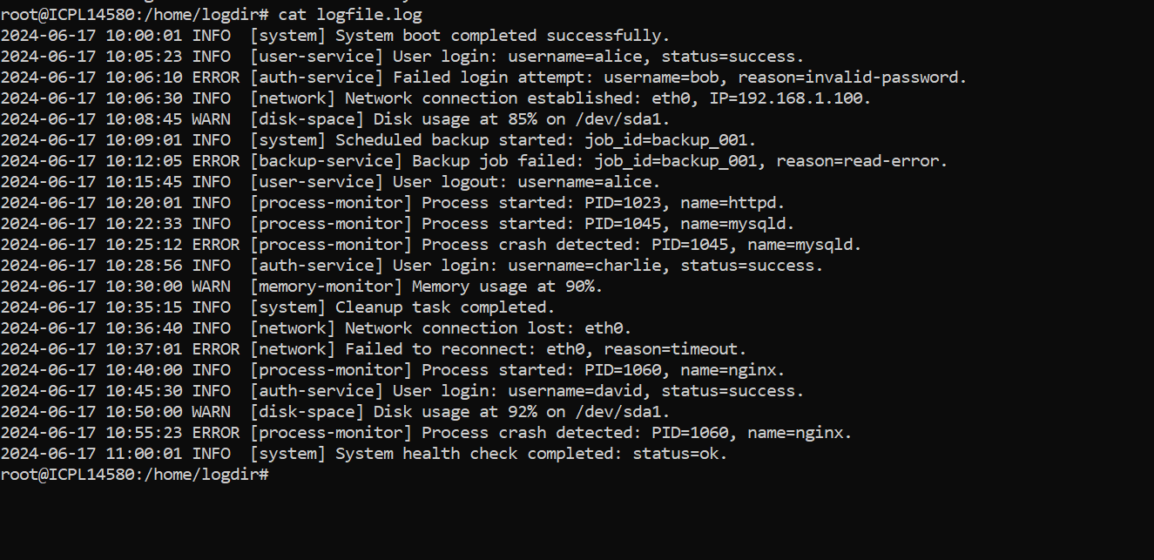

Archiving and Compression

tar -cf backup.tar /home/user/documents

tar -xf backup.tar

gzip file.txt

gunzip file.txt.gz

zip archive.zip file1.txt file2.txt

unzip archive.zip

xz largefile

unxz largefile.xz

tar -czf backup.tar.gz /var/log

tar -xzf backup.tar.gz

zip -r project.zip /home/user/project

xz log1.log log2.log

tar -xzf backup.tar.gz file1 file2

To sync and compress files for remote backup using rsync and gzip

rsync -avz /source/path/ user@remote:/destination/path/

The -z flag compresses data during transfer, saving bandwidth.

Time

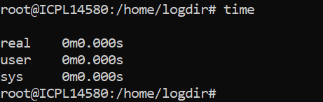

Uname



Hostname



Env

